S.SOUBAN
192312181
Slot: A

Channel Reuse Plan for Multi-User Wireless Communication
Concept: To design and simulate a channel reuse plan for a multi-user wireless communication system by dividing the coverage area into cells and assigning available channels to different cells using a suitable frequency reuse factor, while minimizing co-channel interference.
Matlab Cobe:
clc;
clear;
close all;

% Number of cells
N = 7;

% Total number of available channels
total_channels = 21;

% Channels per cell
channels_per_cell = total_channels / N;

% Frequency reuse factor
reuse_factor = N;

% Cell radius (km)
R = 1;

% Create approximate 7-cell layout
x = [0 1.5 0.75 -0.75 -1.5 -0.75 0.75];
y = [0 0.87 1.73 1.73 0.87 0 -0.87];

% Channel allocation
channel_groups = [
1 2 3;
4 5 6;
7 8 9;
10 11 12;
13 14 15;
16 17 18;
19 20 21
];

% Display channel allocation
disp('Channel Allocation:');
for i = 1:N
fprintf('Cell %d: Channels %d, %d, %d\n', ...
i, channel_groups(i,1), ...
channel_groups(i,2), ...
channel_groups(i,3));
end

% Plot cells
figure;
hold on;
grid on;
axis equal;

theta = linspace(0,2*pi,7);

for i = 1:N
% Hexagonal cell
hx = x(i) + R*cos(theta);
hy = y(i) + R*sin(theta);

fill(hx, hy, 'w');
plot(hx, hy, 'k', 'LineWidth', 1.5);

% Cell number
text(x(i), y(i), sprintf('Cell %d', i), ...
'HorizontalAlignment', 'center', ...
'FontWeight', 'bold');

% Channel numbers
text(x(i), y(i)-0.25, ...
sprintf('Ch: %d,%d,%d', ...
channel_groups(i,1), ...
channel_groups(i,2), ...
channel_groups(i,3)), ...
'HorizontalAlignment', 'center');
end

title('7-Cell Frequency Reuse Plan');
xlabel('Distance (km)');
ylabel('Distance (km)');

hold off;

% Calculate theoretical co-channel reuse distance
D = sqrt(3*N) * R;

fprintf('\nFrequency Reuse Factor = %d\n', reuse_factor);
fprintf('Channels per Cell = %.0f\n', channels_per_cell);
fprintf('Cell Radius = %.2f km\n', R);
fprintf('Co-channel Reuse Distance = %.2f km\n', D);
Output:

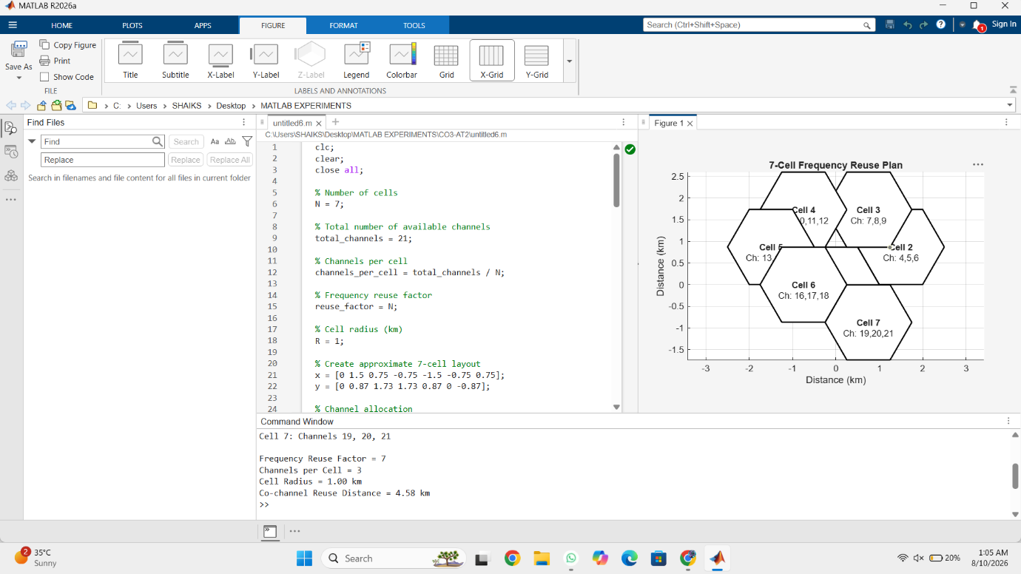
Result: The 7-cell channel reuse plan was successfully simulated in MATLAB. The 21 available channels were divided into 7 cell groups, with 3 channels assigned to each cell. The frequency reuse factor was found to be , and the calculated co-channel reuse distance was approximately 4.58 km for a cell radius of 1 km. This arrangement improves spectrum utilization while reducing co-channel interference.

Smart City Communication Framework for Traffic Monitoring and Surveillance
Concept: To design and simulate a smart city communication framework for real-time traffic monitoring and surveillance using cameras, sensors, wireless communication networks, edge/cloud processing, and a central traffic management system.
Matlab Code:
clc;
clear;
close all;

% Smart City Traffic Monitoring Simulation

% Number of traffic locations
num_locations = 6;

% Number of vehicles detected at each location
vehicles = [35 52 78 45 90 63];

% Average vehicle speed (km/h)
speed = [45 38 25 42 20 32];

% Traffic density levels
density = vehicles / max(vehicles) * 100;

% Communication latency in milliseconds
latency = [25 30 42 28 50 35];

% Packet delivery ratio (%)
PDR = [98 97 95 99 93 96];

% Display results
fprintf('SMART CITY TRAFFIC MONITORING SYSTEM\n');
fprintf('-------------------------------------\n');

for i = 1:num_locations
fprintf(['Location %d: Vehicles = %d, Speed = %d km/h, ' ...
'Density = %.1f%%, Latency = %d ms, PDR = %.1f%%\n'], ...
i, vehicles(i), speed(i), density(i), ...
latency(i), PDR(i));
end

% Identify congested locations
threshold = 70;

fprintf('\nTraffic Status:\n');

for i = 1:num_locations
if density(i) >= threshold
fprintf('Location %d: HIGH TRAFFIC - ALERT GENERATED\n', i);
elseif density(i) >= 40
fprintf('Location %d: MEDIUM TRAFFIC\n', i);
else
fprintf('Location %d: LOW TRAFFIC\n', i);
end
end

% Plot traffic density
figure;
bar(1:num_locations, density);

title('Traffic Density at Different Locations');
xlabel('Traffic Monitoring Location');
ylabel('Traffic Density (%)');
grid on;

% Plot communication latency
figure;
plot(1:num_locations, latency, '-o', 'LineWidth', 2);

title('Communication Latency');
xlabel('Traffic Monitoring Location');
ylabel('Latency (ms)');
grid on;

% Plot packet delivery ratio
figure;
bar(1:num_locations, PDR);

title('Packet Delivery Ratio');
xlabel('Traffic Monitoring Location');
ylabel('PDR (%)');
ylim([85 100]);
grid on;

% Overall average performance
avg_latency = mean(latency);
avg_PDR = mean(PDR);
avg_density = mean(density);

fprintf('\nOverall Performance:\n');
fprintf('Average Traffic Density = %.2f%%\n', avg_density);
fprintf('Average Communication Latency = %.2f ms\n', avg_latency);
fprintf('Average Packet Delivery Ratio = %.2f%%\n', avg_PDR);
OutPut: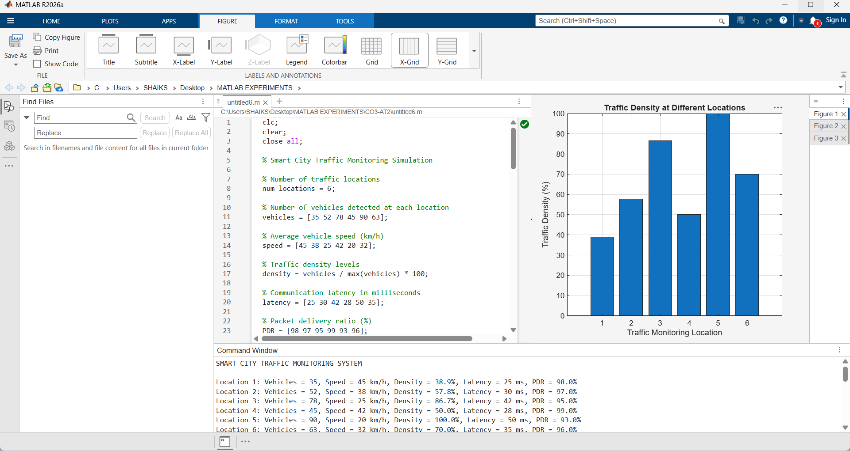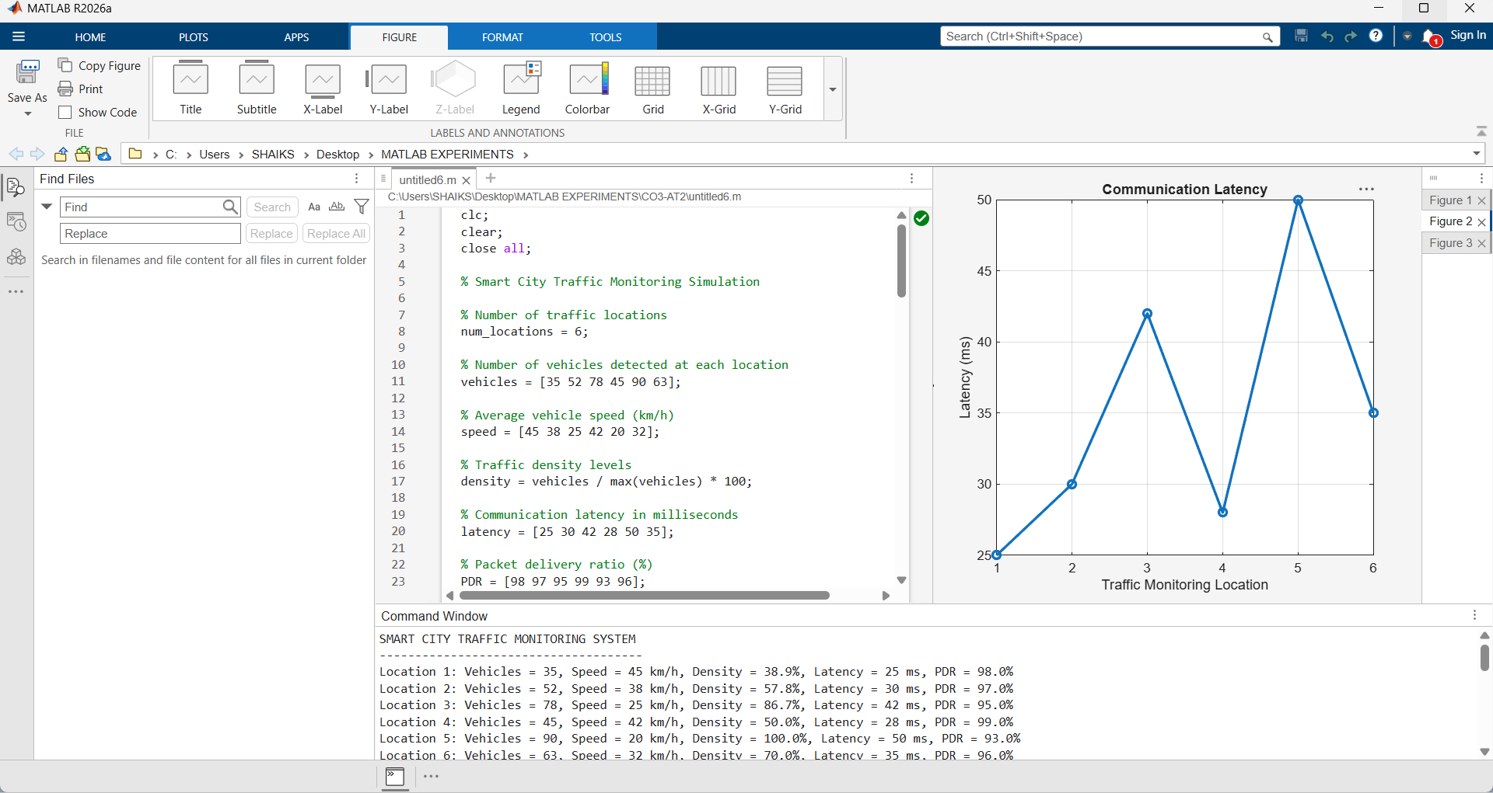
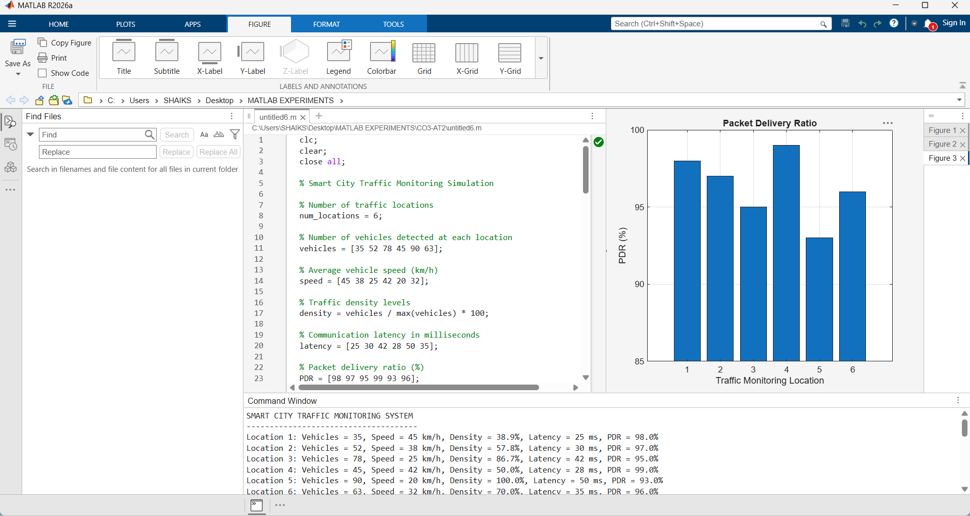

Result: The smart city communication framework for traffic monitoring and surveillance was successfully designed and simulated in MATLAB. The system monitors vehicle density, vehicle speed, communication latency, and packet delivery ratio at multiple locations. Locations with high traffic density are automatically identified and an alert is generated. The framework demonstrates how wireless communication, edge processing, and centralized traffic management can support real-time traffic monitoring and congestion detection.

